**2015 Pacific Island Highlights - Sheri**

**Cycad aulacaspis scale (CAS)**, *Aulacaspis yasumatsui* invaded Guam in 2003. Since initial detection, the scale, and plant health of the native cycad *Cycas micronesica*, has been monitored by Dr. Thomas Marler, University of Guam, in part, with funds from the Cooperative Lands Forest Health Management Program (USDA Forest Service, R5). In November 2015 *Cycas micronesica* was added to the Threatened list under the Endangered Species Act of 1973 (50 CFR Part 17; Federal Register 80(190):59424-59497).

Dr. Marler’s monitoring of cycad populations now includes Guam, Rota, Yap, Tinian and Palau due to continued funding from the Forest Service that supports this critical work. Dr. Marler’s monitoring data from the 2015 indicate that nine years of consistent mortality have occurred on Guam with loss of about 16 trees per hectare per year. Extrapolating this slope generates a prediction of 100% mortality by 2030 if current rates of tree loss are sustained on Guam; the trend is similar for Rota. Yap cycads remain pest-free, with no signs of any of the exotic insect pests. Every plot re-measured in 2015 exhibited extremely high plant density and health. An ex situ collection of Guam genotypes established on Tinian also remains pest-free.

The largest population of *Cycas micronesica* in Palau is on Ngellil Island. The western edge of this population is directly east of where CAS infestations have been sustained for years on planted *Cycas revoluta* plants in commercial landscapes. One meteorological event that shifts wind direction could easily vector CAS crawlers into this wild population. None of the Koror State *Cycas micronesica* populations are exposed to this threat that is caused by geographic proximity. Moreover, one of the popular tourist attractions in Airai State is an abandoned Yap stone money quarry, and the trail that leads to this quarry cuts through this cycad habitat. Any tourist could pick up a CAS crawler as they depart their hotel where the infested *Cycas revoluta* plants are located, then vector that crawler into the native cycad habitat within a short amount of time – this would be devasting. Joel Miles, Bureau of Agriculture, Ann Kitalong, Belau National Museum, Princess Blailes, Governor Adachi’s office, and the Koror State Rangers were critical to the success of Dr. Marler’s exploratory work on Palau. If more funds become available for Palau work, establishing permanent plots within this Ngellil Island habitat is a high priority as well as determining what insect(s) are the pollinators for the Palau population. The pollinator for Guam and Rota is distinct from the Yap pollinator. These are the only two known Lepidoptera cycad pollinators worldwide.

University of Guam entomologist Aubrey Moore continues trying to establish effective biological control for CAS in Micronesia. The lady beetle, *Rhizobius lophanthae*, was introduced from Maui and has been established in Guam, Rota and Palau. This predator protects mature CAS, but it is too large to attack scale insects hiding in many parts of the plant and it does not prey close to the ground, leaving seedlings prone to attack by CAS, resulting in almost 100% mortality. Several attempts at introducing tiny parasitic wasps which might provide more protection than the lady beetle have failed. During 2015, the parasitoid *Coccobius fulvus* was collected from CAS in Florida by Dr. Ron Cave and these were field released on Guam. It is not yet known if these parasitoids became established.

**Coconut rhinoceros beetle** (CRB), *Oryctes rhinoceros*, first detected on Guam in 2007 defied containment and eradication efforts. These efforts included the release of the *Oryctes* nudivirus that weakens and kills adults. Later testing showed this virus to be ineffective against the genetically different biotype of CRB on Guam. This biotype is more vigorous and destructive than the commonly occurring CRB. The Guam biotype was also found in Hawaii in 2013. Palau has both biotypes.

Adult CRB kill palms when they bore into crowns to feed on sap. Rhino beetle larvae feed only on dead plant material at breeding sites and they do no damage. In order to eradicate rhino beetles, all breeding sites must be found and destroyed. Four dogs were trained to lead handlers to cryptic breeding sites on Guam. This detector dog program was effective but very expensive and it was shut down after a couple of years.

Aubrey Moore, a UOG entomologist, suggested following radio-tagged rhino beetles to breeding sites as a cost-effective alternative to using detector dogs. In August 2015 this idea was tested in a small feasability study on Guam supported by a Forest Service grant. The research team included Moore, Dr. Matthew Siderhurst and his students, Kat Lehmann and Diego Barahona from Eastern Mennonite University, VA, Domenick Skabeikis from the USDA Pacific Basin Research Center in Hilo, HI and UOG technician Ian Iriarte.

During the 10 day field trial, miniature radio transmitters were glued to the backs of rhino beetles (Fig. a). These beetles were released at the UOG Agricultural Experiment Station in Yigo and at the Asan Beach Park and their locations were tracked for a few days using special radio receivers equipped with directional antennas.

The majority of beetles were tracked to coconut trees which had already been damaged by rhino beetles. A few other beetles quickly flew beyond the detection range of the receivers and were never recovered. As hoped, several beetles lead the team to cryptic breeding sites. The transmitter from one of the first beetles to be released was found the next day in a hole in a rotting branch of a breadfruit about 20 feet above the ground. Three other adult beetles were found in the same hole indicating that the beetles had aggregated here to establish a new breeding site. According to Moore, “It is very likely that the breadfruit branch was broken during Typhoon Dolphin which visited Guam in May 2015. If this is the case, there must be thousands of new, miniature breeding sites in Guam's jungles resulting from typhoon damage. These breeding sites will be generating large numbers of adult rhino beetles within the next several months.” Another unexpected result from the field trial is the fact that none of the 30 tagged beetles were caught in traps, even though all were released within pheromone trapping grids. This indicates that rhino beetle pheromone traps may be useful for detection and surveillance but are ineffective for population control.

Cryptic breeding sites can be found by following radio-tagged beetles and this method may be a critical to the success of eradication attempts on a recently invaded islands.

Figure a. 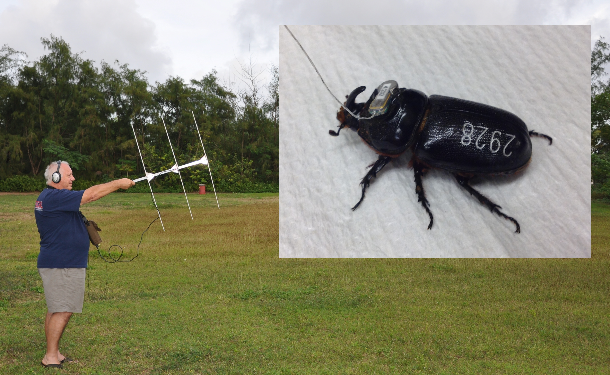Radio-tracking receiver and coconut rhinoceros beetle with transmitter glued to pronotum.

Figure 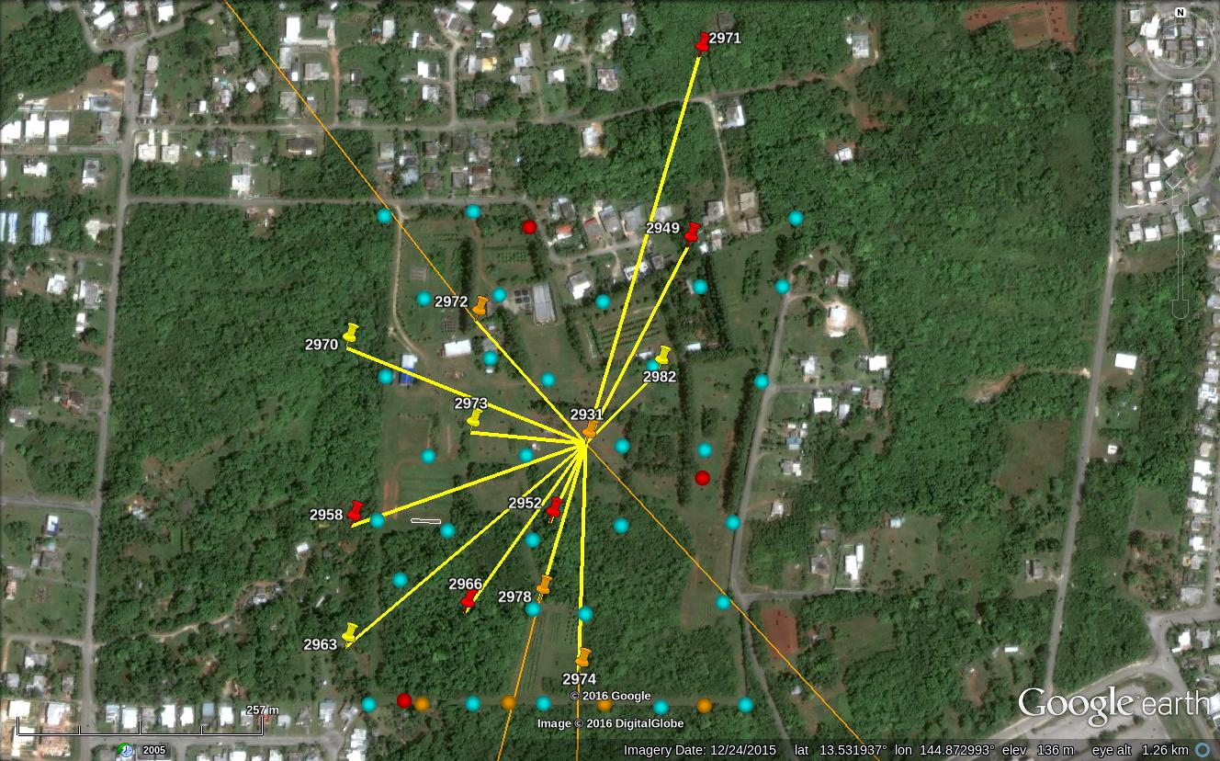b. Displacement of radio-tracked beetles at the Yigo release site on Guam. Push pin icons represent end points (red = in tree; yellow = on or below the ground; orange: beetle was lost

when it flew beyond the range of radio-tracking receivers. Circles represent pheromone traps.

US Forest Service is also supporting CRB detection efforts on Saipan, Tinian and Rota. Typhoon Soudelor struck and severely damaged Saipan in late August 2015, rendering travel there, and to adjacent islands, very difficult. Winds in excess of 120 MPH destroyed or severely damaged all of the CRB traps on Saipan, destroyed office and laboratory facilities used for the CRB detection project, rendered travel within Saipan difficult until clean-up was effected, and forced airlines to cancel most flights to Tinian and Rota from Saipan until runways could be restored on Saipan. Restoration of most of Saipan’s infrastructure took until early December 2015. Following the typhoon, “DeFence” traps were established and/or repaired on Saipan and Tinian. These traps consist of a doubled layer of tekken fish netting with a 1 cm mesh size which is attached to a cyclone fence with plastic ties. A CRB pheromone bait and a solar-powered UV LED is attached to the center of the net. The tekken netting acts as similarly to a gill net that entangles the thorax of rhino beetles attracted to the light or pheromone. CRB traps (various types) were established/re-established on Saipan, Tinian (Figure ?) and on Rota (Figure ?) following the typhoon. No CRB detections occurred in 2015.

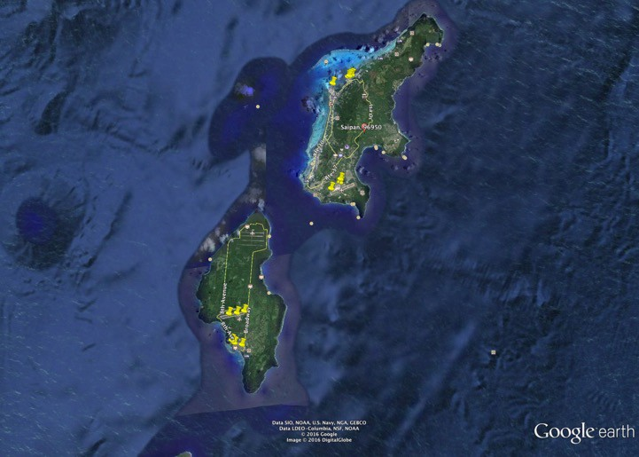

Figure ?. Location (yellow pins) of CRB DeFence traps on Saipan (above) and Tinian (lower). (Source: Dr. Ross Miller, University of Guam)

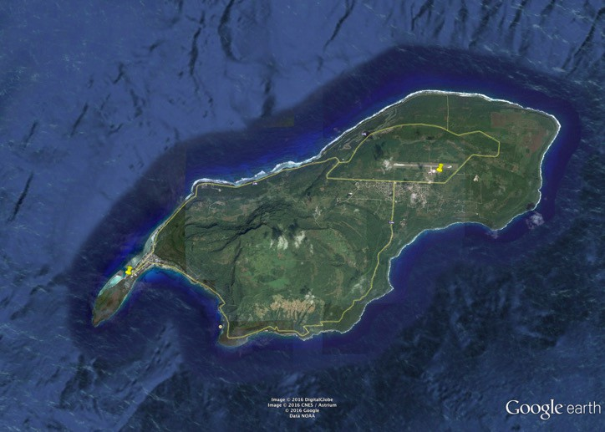

Figure ?. Location of CRB traps on Rota at the airport (center) and at the West Dock (Left). (Source: Dr. Ross Miller, University of Guam)

The **little fire ant** (LFA), *Wasmannia auropunctata* was detected on Guam in late 2011 by staff of the Guam Coconut Rhinoceros Beetle Eradication Project as they were being bitten by the ants while unloading plant material at the dump. LFA attend mealybugs, scales and other insects which can protect them from natural enemies and move them from leaf to leaf and plant to plant. This can result in stunting of growth, premature fruit excision, and fruit spoilage. LFA is an arboreal ant species that loves shade and moisture, walking through the forest, enjoying outdoor activities and gardening is almost impossible in infested areas. Management of and surveying for LFA on Guam are being supported by the US Forest Service. Several new sites were sampled in 2015 including three sites selected by the Government of Guam to be reception areas for green debris generated from throughout Guam by Typhoon Dolphin, which hit in May 2015. These sites were located at the University of Guam’s Ija Experiment Station in southern Guam, at Oka Point near Ypao Beach in east-central Guam, and along Wusstig Road in northern Guam. LFA was identified at the Oka Point site so it was added as a treatment site. Treatment consists of a granular formulation of Amdro® or the more water-resistant granular formulation of Siesta®, followed a week later by Tango® applied to the upper boles of trees within a gel matrix. A week following the Tango® application delimiting surveys are conducted again. This sequence is repeated every six weeks during this reporting period. Sites which had been treated in this manner 8 times as per the University of Hawaii Ant Lab protocol, and in which LFA occurrence in baits fall to 0 (Figures PHOTO and GRAPH), are removed from treatment, and the property owners/managers are informed of strategies to keep LFA from re-infesting their property in the future.

# 

Figure ?. Map of the WWII Veteran’s Park on Guam showing the results of the initial delimiting survey conducted. Flags in red indicate baits on which LFA were collected; yellow flags indicate sampling sites where no LFA were collected on the baits. No LFA were collected after the 7th treatment episode. (Source: Dr. Ross Miller, University of Guam)

Figure ?. Percentage decrease in the number of baits infested by little fire ant at six treatment sites (X axis = Delimiting Survey and LFA Treatment Episodes, Y axis – Percent Baits with LFA). No little fire ants were detected following the 7th and 8th treatments at any of the sites, and further treatment at all sites was terminated. (Source: Dr. Ross Miller, University of Guam)

**New Pest Detections**

*Serianthes nelsonii* seedlings attacked by bark beetle (from Aubrey) and photos?: INCLUDED IN SEPARATE FILE

In February 2015, citrus greening disease or huanglongbing (HLB) (*Candidatus* sp., bacteria) was detected on Guam, which was the first detection of HLB in the American Affiliated Pacific Islands. Most citrus species, plus orange jasmine (*Murraya paniculata*), box orange (*Severinia buxifolia*), and several other species in the family Rutaceae are hosts. Some weeds are also hosts of HLB; limeberry (*Triphasia trifolia*) is widespread on Guam, making eradication of the bacterium almost impossible. HLB is vectored by the Asian Citrus psyllid (*Diaphorina citri*) which is present on the Pacific Islands of Guam, American Samoa and Hawaii, as well as mainland US and in several other countries.

**New Pacific Pests and Pathogens Phone App**

A new phone app was released by Grahame Jackson and his colleagues at PestNet (http://www.pestnet.org/). The app is free and can be downloaded for Apple and Android devices. After choosing a plant of interest, a series of questions are asked to narrow the choices until a pest match is made and compared with thumbnail images. This app gives extension staff and growers information they need to manage pests. There are over 230 fact sheets that provided information on damage, pest biology and life cycle, and management. (Information provided by Dr. Aubrey Moore, University of Guam *in* [Pacific Pest Detector News, Sept. – Nov. 2015](http://www.npdn.org/system/files/WPDN PPDNews_No23_Sep2015.pdf))

There is also a new cell phone app for identifying Pacific scarab beetles – will send separate email on this in case you want to include here.